ST. XAVIER'S COLLEGE

**(Affiliated to Tribhuvan University)**

Maitighar, Kathmandu



**COMPUTER GRAPHICS**

**LAB ASSIGNMENT # 1**

**SUBMITTED BY:**

Apil Neupane  
013BSCCSIT008

**SUBMITTED TO:**

|  |  |
| --- | --- |
| **Er. Anil k. Sah**  Lecturer,  Department of Computer Science  St. Xavier’s College |  |

**Date of Submission:** 4th August 2015

**STATEMENT:**

**A PROGRAM TO DRAW CHECK BOX**

**SOURCE CODE:**

//---------------------------------------------------------------------------

#include <vcl\vcl.h>

#pragma hdrstop

#include "SC2.h"

//---------------------------------------------------------------------------

#pragma resource "*.dfm"

TForm1 *Form1;

//---------------------------------------------------------------------------

__fastcall TForm1::TForm1(TComponent* Owner)

: TForm(Owner)

{

}

//---------------------------------------------------------------------------

void __fastcall TForm1::Button1Click(TObject *Sender)

{

Form1->Canvas->Pen->Width=3;

Form1->Canvas->Brush->Color=clRed;

Form1->Canvas->Rectangle(10,10,210,210);

Form1->Canvas->MoveTo(10,10);

Form1->Canvas->LineTo(210,210);

Form1->Canvas->MoveTo(210,10);

Form1->Canvas->LineTo(10,210);

Form1->Canvas->MoveTo(10,110);

Form1->Canvas->LineTo(210,110);

Form1->Canvas->MoveTo(110,10);

Form1->Canvas->LineTo(110,210);

Form1->Canvas->MoveTo(10,60);

Form1->Canvas->LineTo(210,60);

Form1->Canvas->MoveTo(10,160);

Form1->Canvas->LineTo(210,160);

Form1->Canvas->MoveTo(60,10);

Form1->Canvas->LineTo(60,210);

Form1->Canvas->MoveTo(160,10);

Form1->Canvas->LineTo(160,210);

}

//---------------------------------------------------------------------------

**OUTPUT:**

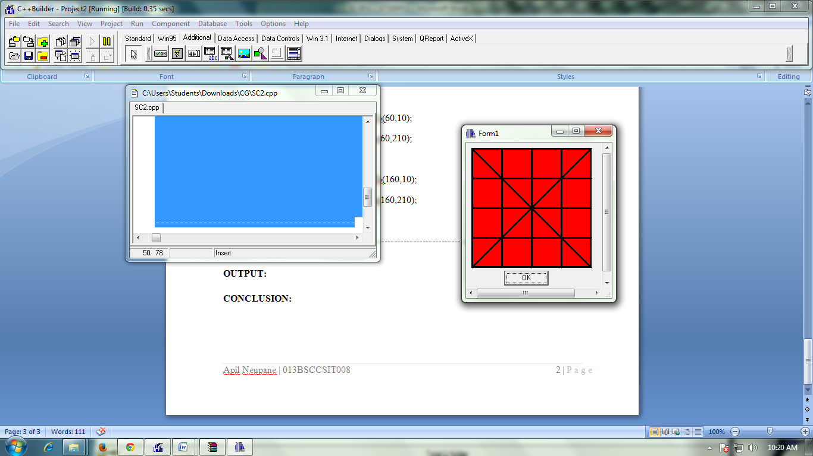

**CONCLUSION:**

Here, we build a simple rectangle and the plotted it with the help of different lines by calculating the coordinates and finally check box was formed.

Thus, checkbox was drawn using C++ Builder..